Date:

Payer Company Name
Street/Building Address
City, State ZIP

ATTN: Contact Name/ Contact Title

Re: Letter of RYTARY Medical Necessity for Plan Member Name

Plan member information:
Name: First and Last Name
Date of Birth: MM/DD/YYYY
ID Number: Insurance ID Number
Group Number: Insurance Group Number

Dear Sir or Madam:

This letter is to explain the rationale for my prescription of carbidopa and levodopa extended-release capsules (RYTARY®) for patient name. This individual suffers from Parkinson’s disease (PD) for which RYTARY has been FDA approved.¹
This patient was recently diagnosed with PD, and it is well recognized by experts that carbidopa/levodopa is an effective drug treatment for PD. This drug results in improvement in motor function and quality of life, and it is now widely recognized on the basis of large clinical trials that levodopa is the gold standard of treatment for PD.^{2,3}
Currently, there are 4 forms of levodopa on the US market, all of which have been FDA approved for use in PD. These include Sinemet® (immediate-release carbidopa/levodopa), Sinemet® CR (controlled-release carbidopa/levodopa), Stalevo® (carbidopa/levodopa/ entacapone), and RYTARY.⁴⁻⁶ While all 4 products consist of the same active ingredients (carbidopa/levodopa), they differ in their plasma concentration–time profiles.⁷
The importance of the plasma concentration profile of levodopa can be understood by a careful review of the seminal paper by Albin and Leventhal, which discusses in detail the normal physiology of the dopamine system and how it is disrupted in PD. The key point of this paper is that the paracrine (long-lasting) effects of dopamine in the brain is essential for counteracting the cardinal features of PD (slowing of movement, rigidity, and resting tremor). We learn from this paper that any pharmacological agent that replaces dopamine in the brain will ideally exert long-term stimulation of dopamine receptors, which in turn is achieved by using a drug with the longest plasma concentration–time profile.⁸ An ideal therapy option must contain not only a long plasma concentration–time profile, but also a favorable safety profile.
Another important rationale for using a long-lasting carbidopa/levodopa formulation is that, as long as plasma levels stay in the therapeutic window, it will lead to fewer dyskinesias than shorter-lasting formulations. Dyskinesias, abnormal movements that develop with time in patients taking levodopa, can be very disabling and often necessitate additional drug therapy to control. Studies have shown that dyskinesias associated with the pulsatile nature of the traditional delivery of levodopa plasma levels could possibly be prevented or even reversed with the continuous stimulation of longer-lasting treatments when plasma levels are sustained within the therapeutic window.⁹
Figure 1, which compares the mean plasma concentration–time profiles of the 4 available forms of carbidopa/levodopa, shows that RYTARY sustains levodopa levels for 1.9 to 2.5 hours longer than the other carbidopa/levodopa treatments.⁷ This study supports the rationale to use RYTARY instead of the other carbidopa-levodopa products because the clinical goal is to achieve long-lasting dopamine receptor stimulation in a fashion that most closely mimics the way the normal brain produces and releases this important neurotransmitter.
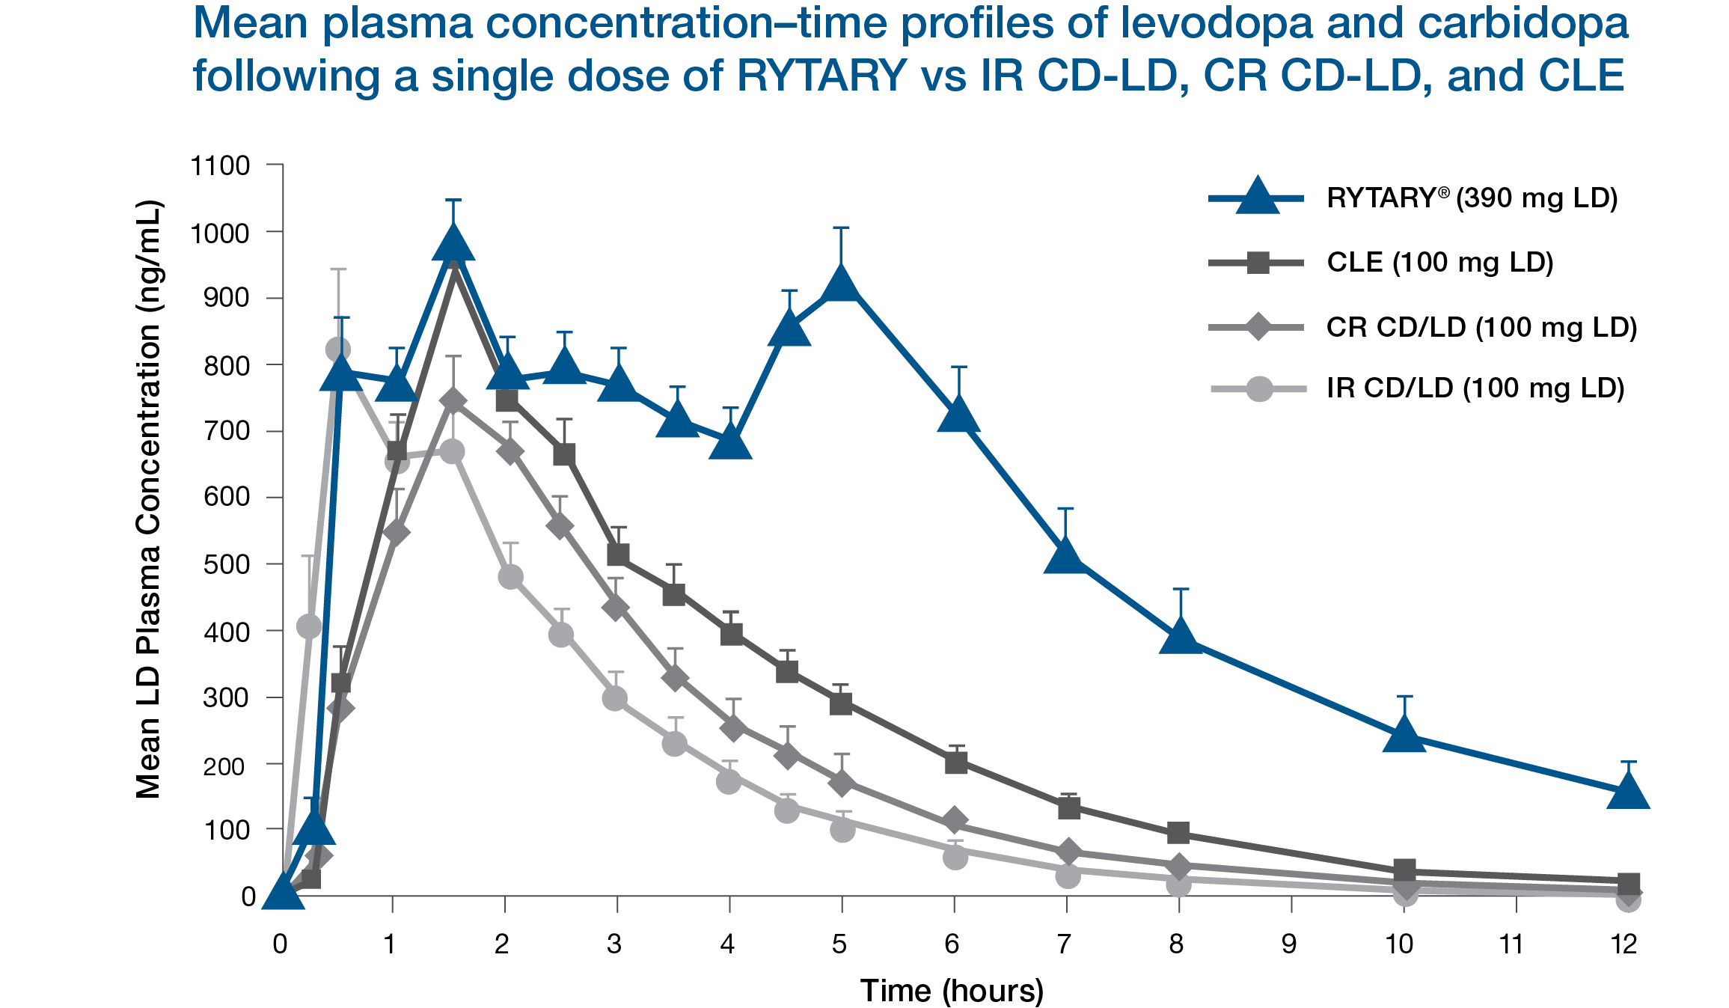
In a 30-week study, RYTARY provided significant clinical benefits in the mental activity and activities of daily living in levodopa-naïve patients. This study also demonstrated the safety of RYTARY. During the study only 2.9% of patients experienced any sort of dyskinesia and that number was only 2.3% for patients taking the lowest dose of RYTARY.¹⁰ In the 9-month, open-label extension of this study, the incidence of dyskinesia reported by patients with early PD taking RYTARY was only 1.9%.¹¹
Beyond the theoretical rationale that the pharmacological agent with the longest plasma concentration–time profile will exert the longest stimulation of dopamine receptors, it is important to note that the benefits of RYTARY were achieved in patients without troublesome dyskinesia.¹² In my opinion, RYTARY would be the most appropriate treatment option for my patient.
In light of the foregoing considerations, it is essential that you approve RYTARY for my patient. It is my view that use of other preparations of levodopa will lead to more motor fluctuations, which could result in harm to my patient and a significantly higher cost of care in the future.^{13,14}
Sincerely,
Signature line

REFERENCES
1. RYTARY [package insert]. Bridgewater, NJ: Amneal Specialty, a division of Amneal Pharmaceuticals LLC; 2019. 2. Poewe W, Antonini A, Zijlmans JCM, Burkhard PR, Vingerhoets F. Levodopa in the treatment of Parkinson’s disease: an old drug still going strong. Clin Interv Aging. 2010;5(1):229-238. 3. Ovallath S, Sulthana B. Levodopa: history and therapeutic applications. Ann Indian Acad Neurol. 2017;20(3):185-189. 4. Sinemet [package insert]. Whitehouse Station, NJ: Merck Sharp & Dohme Corp., a subsidiary of Merck & Co., Inc.; 2014. 5. Sinemet CR [package insert]. Whitehouse Station, NJ: Merck Sharp & Dohme Corp., a subsidiary of Merck & Co., Inc.; 2018. 6. Stalevo [package insert]. East Hanover, NJ: Novartis Pharmaceuticals Corporation; 2019. 7. Hsu A, Yao H-M, Gupta S, Modi NB. Comparison of the pharmacokinetics of an oral extended-release capsule formulation of carbidopa-levodopa (IPX066) with immediate-release carbidopa-levodopa (Sinemet®), sustained-release carbidopa-levodopa (Sinemet® CR), and carbidopa-levodopa-entacapone (Stalevo®). J Clin Pharmacol. 2015;55(5):995-1003. 8. Albin RL, Leventhal DK. The missing, the short, and the long: levodopa responses and dopamine actions. Ann Neurol. 2017;82(1):4-19. 9. Olanow CW, Obeso JA, Stocchi F. Drug insight: continuous dopaminergic stimulation in the treatment of Parkinson's disease. Nat Clin Pract Neurol. 2006;2(7):382-392. 10. Pahwa R, Lyons KE, Hauser RA, et al; APEX-PD Investigators. Randomized trial of IPX066, carbidopa/levodopa extended release, in early Parkinson’s disease. Parkinsonism and Related Disorders. 2014;20(2):142-148. 11. Waters CH, Nausieda P, Lyudmila D, et al. Long-term treatment with extended-release carbidopa–levodopa (IPX066) in early and advanced Parkinson’s disease: a 9-month open-label extension trial. CNS Drugs. 2015;29(4):341-350. 12. Hauser RA, Hsu A, Kell S, et al; IPX066 ADVANCE-PD Investigators. Extended-release carbidopa-levodopa (IPX066) compared with immediate-release carbidopa-levodopa in patients with Parkinson’s disease and motor fluctuations: a phase 3 randomised, double-blind trial. Lancet Neurol. 2013;12(4):346-356. 13. Arnold RJG, Layton A, Rustay NR, Chen S. Cost-effectiveness of extended-release carbidopa-levodopa for advanced Parkinson’s disease. Am J Pharm Benefits. 2017;9(1):23-29. 14. Findley LJ, Wood E, Lowin J, Roeder C, Bergman A, Schifflers M. The economic burden of advanced Parkinson’s disease: an analysis of a UK patient dataset. J Med Econ. 2011;14(1):130-139.

PP-HCP-RYT-US-0120 05/2020

